**IICT project report**

Fahad Alam 21I-2495

Azmeer Sohail 21I-2977

Page1: Login

This page allows user to sign in by entering their respective username and password. They can then sign in by clicking the sign in button. There is also a forgot password button for anyone who forgets their password.

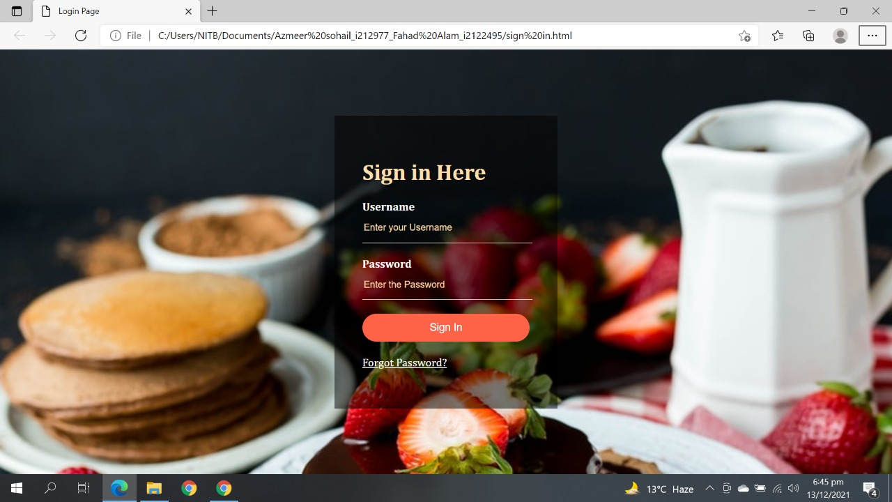

Page 2: Home

This is the main home page of the website and gives a glimpse of the types of food offered by our restaurant. It shows we have takeaway at the top left corner. There is a navigation bar at the top which allows the user to visit the Menu, Deals, Cart and Contact pages via clicking.

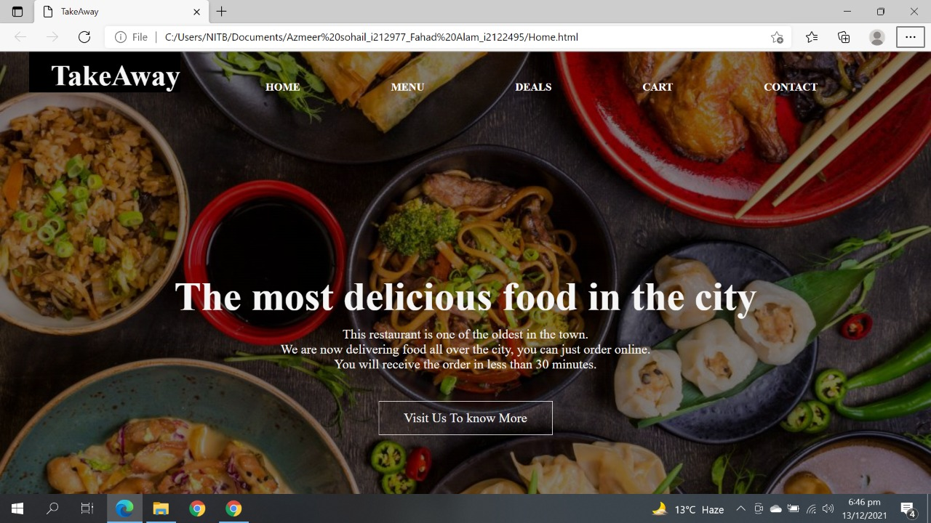

Page 3: Menu

This page displays the menu of our restaurant. User can add click on the add to cart button in front of any item to add the item to their cart. They can access all other pages of our website via the navigation bar at the top by clicking.

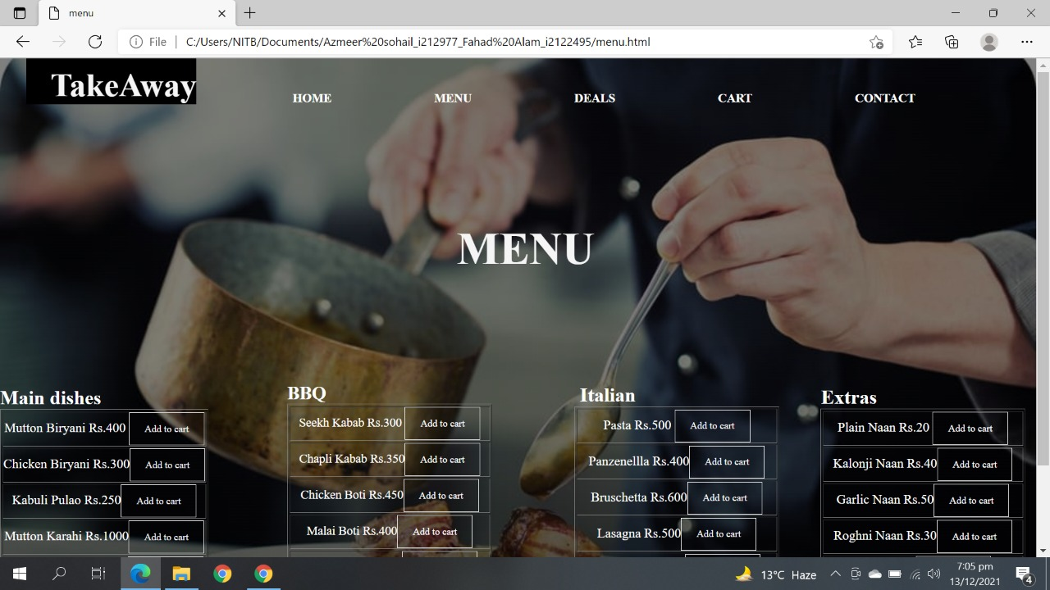

Page4: Deals

This page is the page which displays the ongoing deals at our restaurant. There are a total of three deals. Their items and photos as well as prices are displayed. The user can add any deal to their cart by clicking on the checkbox beside the add to cart text. The navigation bar is available to allow user to navigate to the other pages.

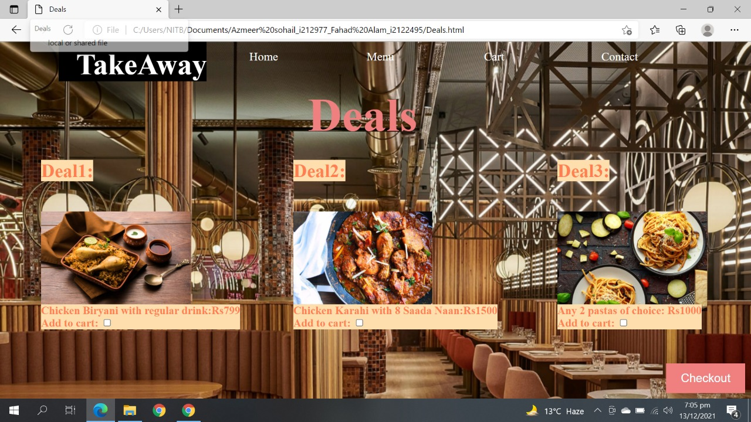

Page 5: Cart

The cart page displays the different items the user has added to their cart. The images, quantity and prices of the items are displayed. Below this is the Final Bill, according to the items and their quantity. At the bottom left, there is a checkout button which takes the user to the payment page upon clicking it.

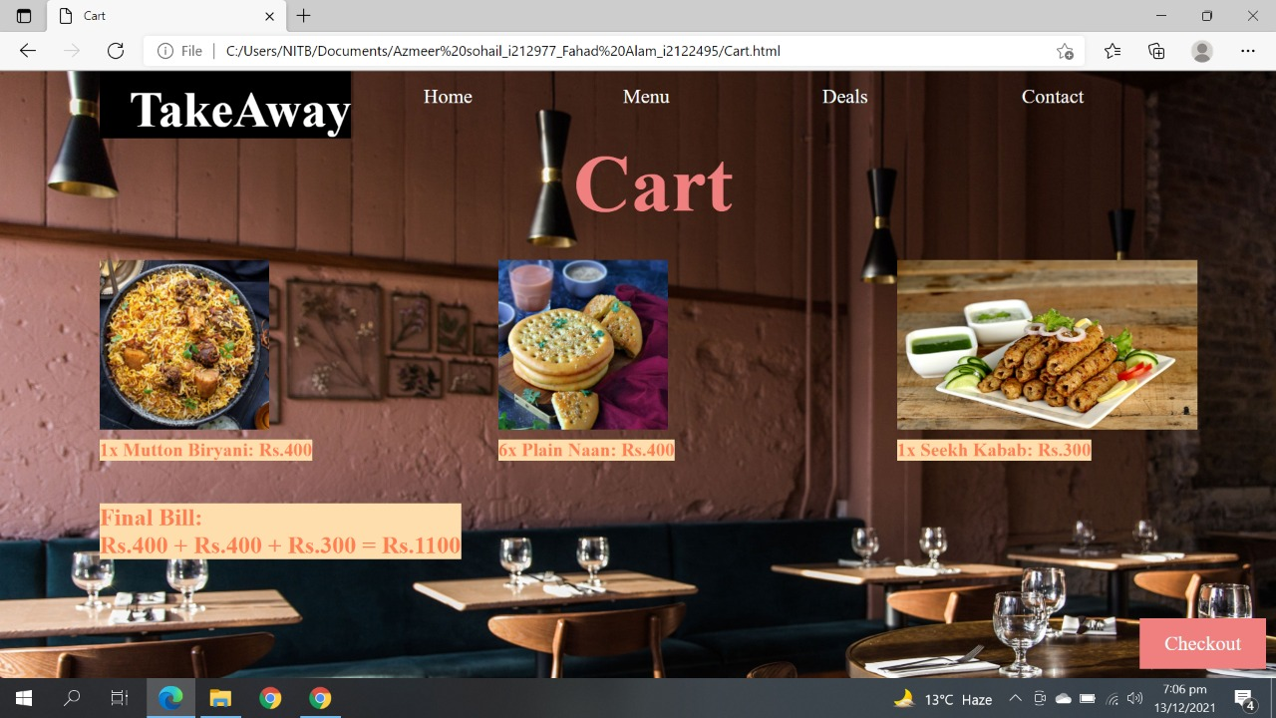

Page6: Payment

The payment page asks user to enter their Name, Email, Contact number and Shipping address. The user then has to select their desired payment method. After all of this, the user clicks on the Place and Order button to finalize their order. The page has a navigation bar in case the user wants to visit the other pages or add other items or change their order.

